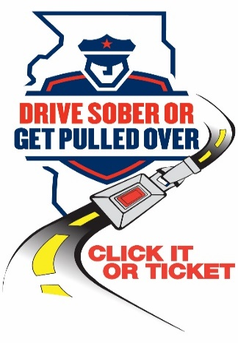

NEWS
FOR IMMEDIATE RELEASE
Date: 14 August 2026

For Information, Contact:
Name: Deputy Chief Cruz Ortiz Jr.
Phone Number: 708-788-2131
Email: cruz.ortiz@stickneypolice.com

The Stickney Police Department joins statewide Labor Day traffic safety effort focused on impaired, distracted and unsafe driving

Stickney, IL – The Stickney Police Department is proud to be one of over 200 law enforcement agencies across Illinois participating in the statewide “Drive Sober or Get Pulled Over,” “Drive High. Get a DUI” and “Click It or Ticket” campaigns this Labor Day. From Aug. 14 through the early morning hours of Sept. 8, officers will be out in force, focused on stopping impaired driving, enforcing seat belt laws and reducing other dangerous driving behaviors.
“Driving under the influence — whether it’s alcohol, cannabis or any other impairing drug — is not just risky, it’s illegal,” said Deputy Chief Cruz Ortiz Jr. “We’ll be patrolling with zero tolerance for impaired driving, because our goal is to protect the people of the Village of Stickney.
Officers will also be enforcing seat belt laws as part of the “Click It or Ticket” initiative. Buckling up is the most effective way to prevent serious injury or death in a crash. Everyone in the vehicle — front seat or back — should be properly buckled, every trip.

In addition to alcohol, officers will be on the lookout for drivers impaired by cannabis and other drugs. Messages like “Drive Sober or Get Pulled Over” and “Drive High. Get a DUI” are part of a statewide education and enforcement effort aimed at saving lives.

“We want our community to enjoy the holiday weekend safely and responsibly,” said Deputy Chief Cruz Ortiz Jr. “Plan ahead, use a designated driver, and never get behind the wheel impaired. These decisions save lives.”

This local effort is part of a larger statewide campaign supported by the Illinois Department of Transportation, which administers the “Drive Sober or Get Pulled Over” and “Click It or Ticket” campaigns with federal highway safety funds. The initiative is reinforced by IDOT’s “It’s Not a Game” media campaign running across radio, TV and digital platforms to highlight the deadly consequences of impaired driving.

